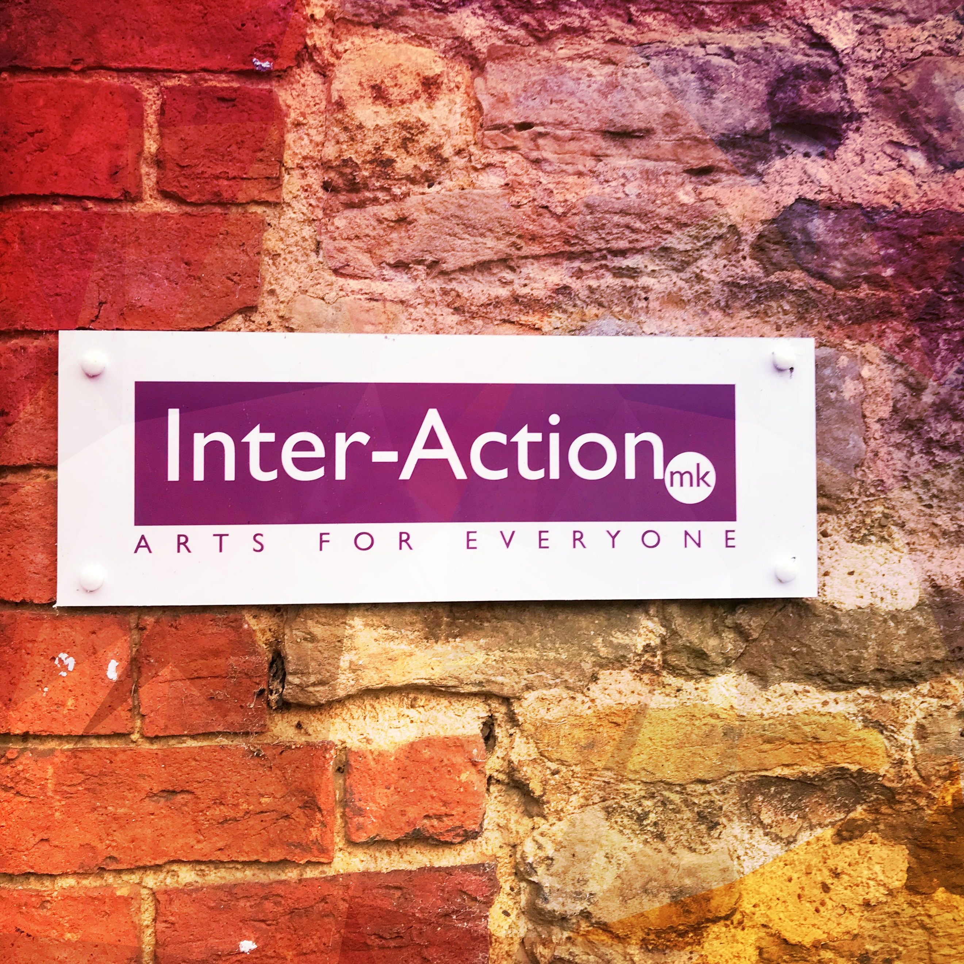
British Values Workshops in Schools. Summer 2018. Evaluation
Thanks for taking part in Inter-Action’s British Values project and for making it such a success. It helps us to plan better future projects to get honest feedback from our partners.
Can you make some comments under the headings below and email it back to Jesita at manager@interactionmk.org.uk

Thanks for your time and look forward to hearing from you.

Name of School and Contact

Why did you want to take part in the project and Did the project fulfil your Aims- Could you give some specifics?

Can you talk about the quality of:
- Management and organisation
- The Sessions
- The Outcomes

Would you be interested in future project opportunities with Inter-Action MK ?

Any other comments

Thank You

