LONG MEADOW SCHOOL
Garthwaite Crescent, Shenley Brook End, Milton Keynes, MK5 7XX
(01908 508678 – fax: 01908 520630)
e-mail: office@longmeadow.milton-keynes.sch.uk
web: www.longmeadow.milton-keynes.sch.uk

Headteacher: Mr Philip Gray BEd (Hons) CANTAB, NPQH

Thursday May 28 2020

Dear Parents and Carers

This week we have had to do one of the most heart wrenching jobs possible. This week we have had to dismantle our school in preparation for next week's opening. We have had to pack away all of the soft furnishings, all non-essential items etc as per government guidelines. This means that the school we work so hard on being warm, welcoming and open, has had to be turned into the complete opposite. As I have said many times before, the school we knew is now not that school in every way.

Below you will see a typical classroom set up. One for KS1 and KS2 and one for EYFS.
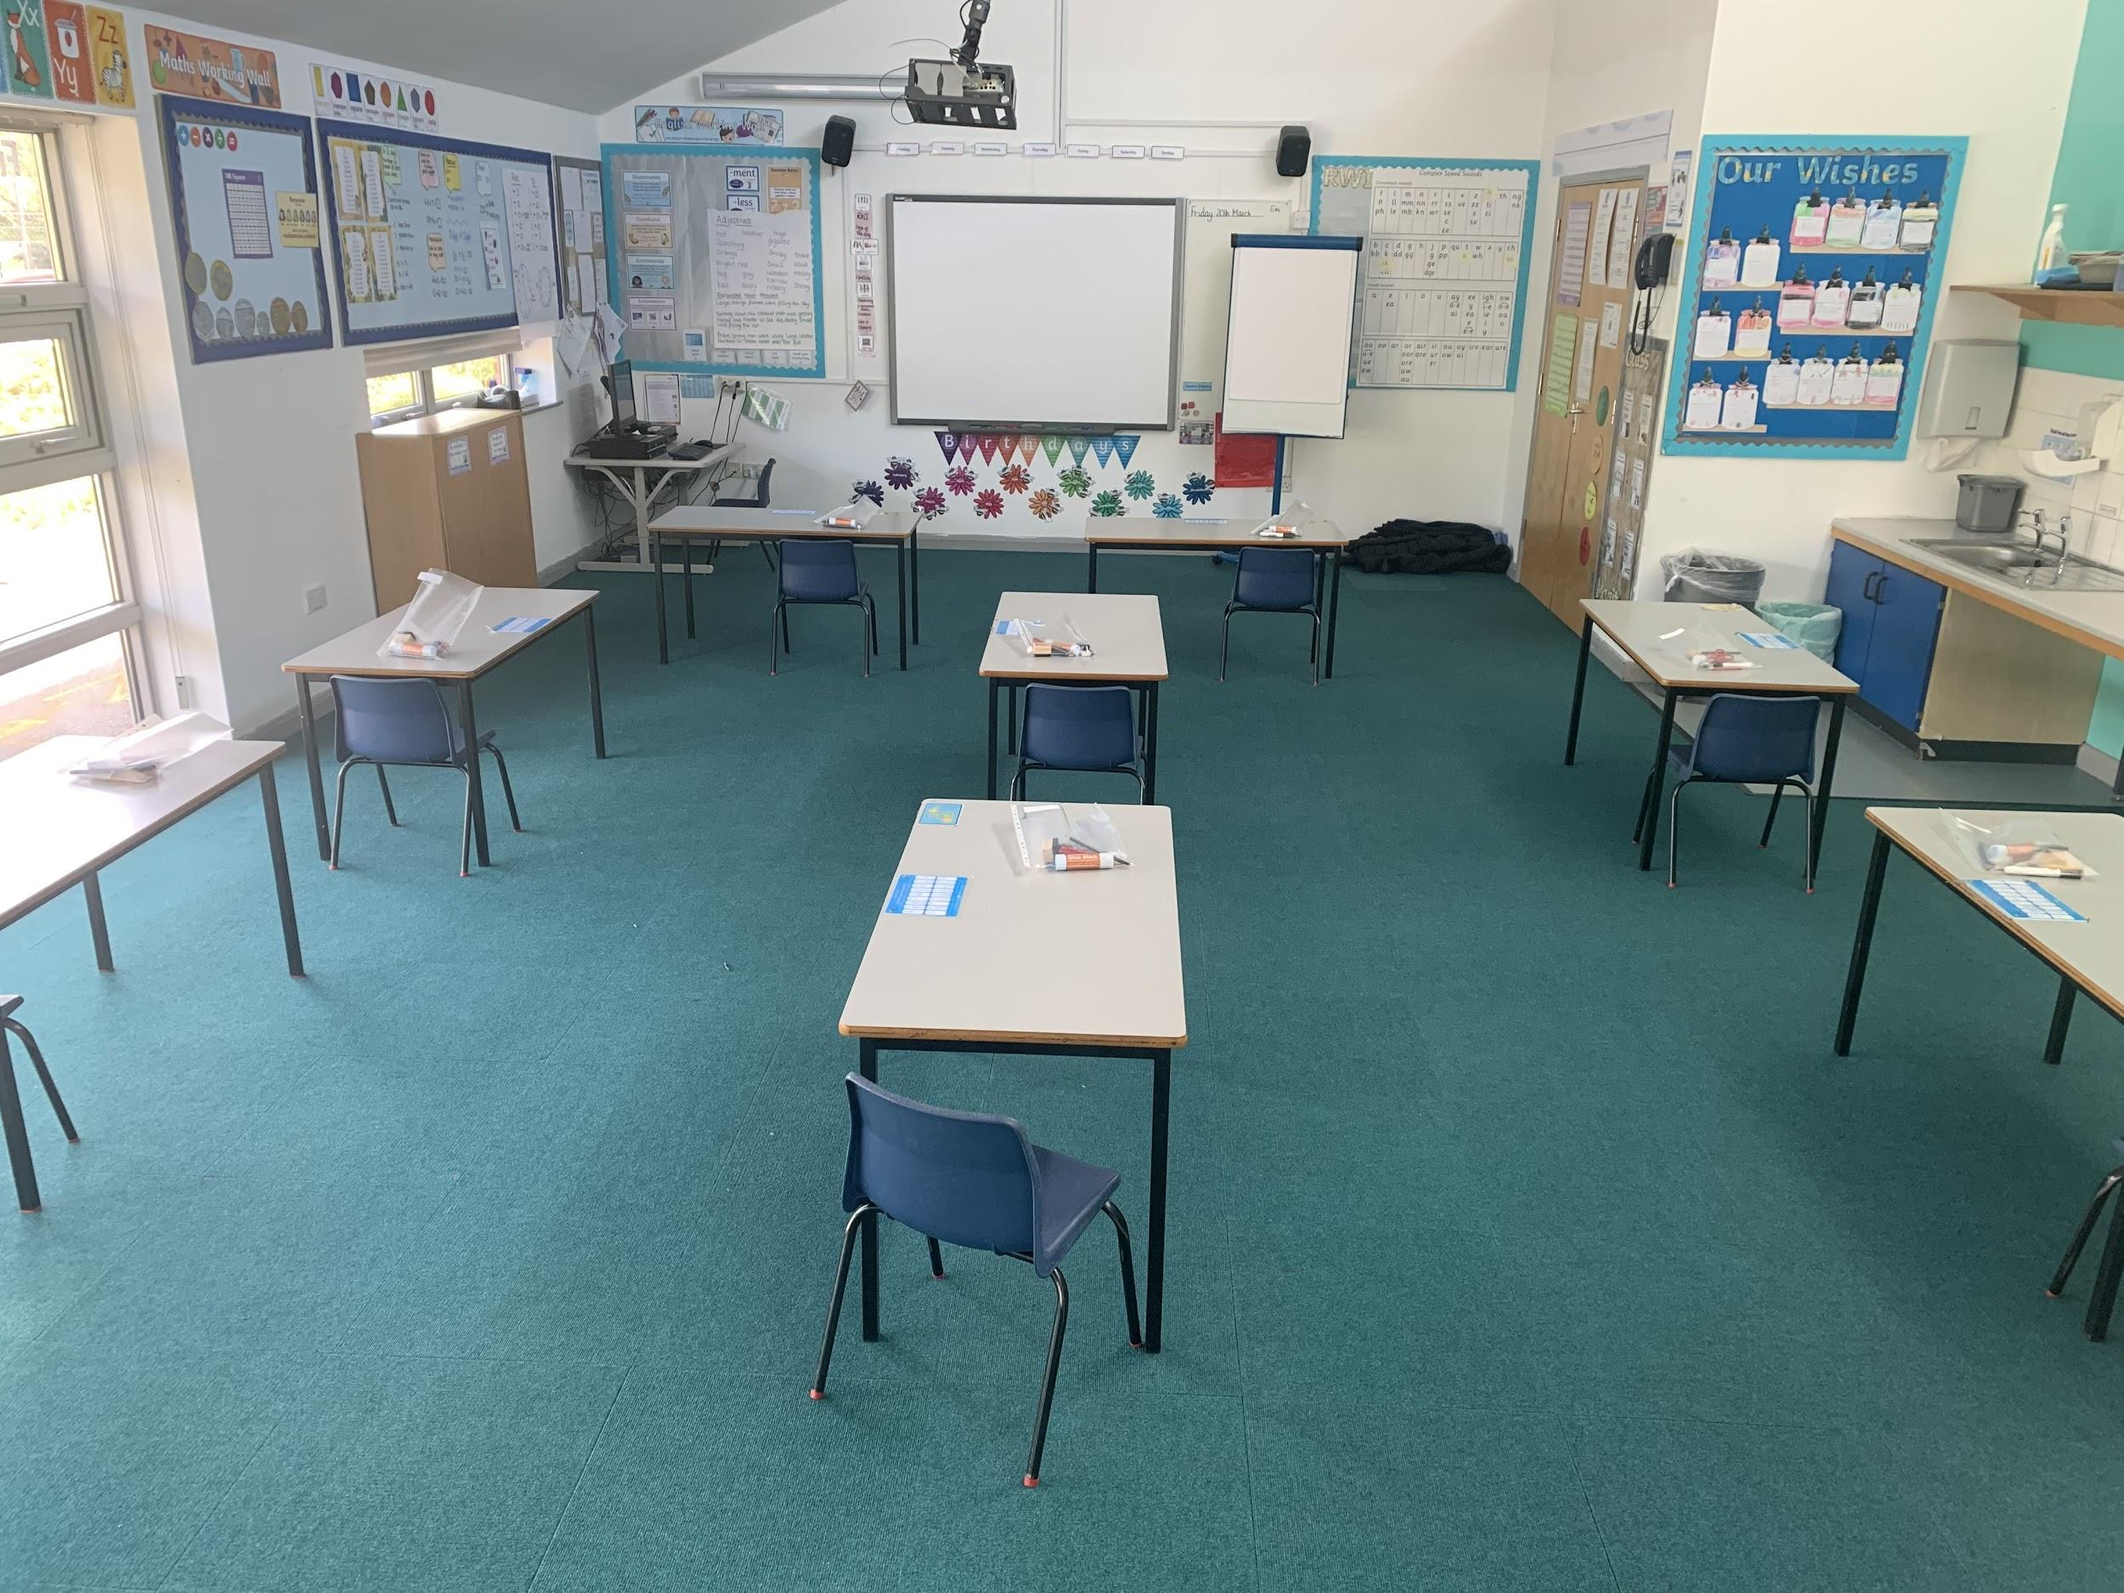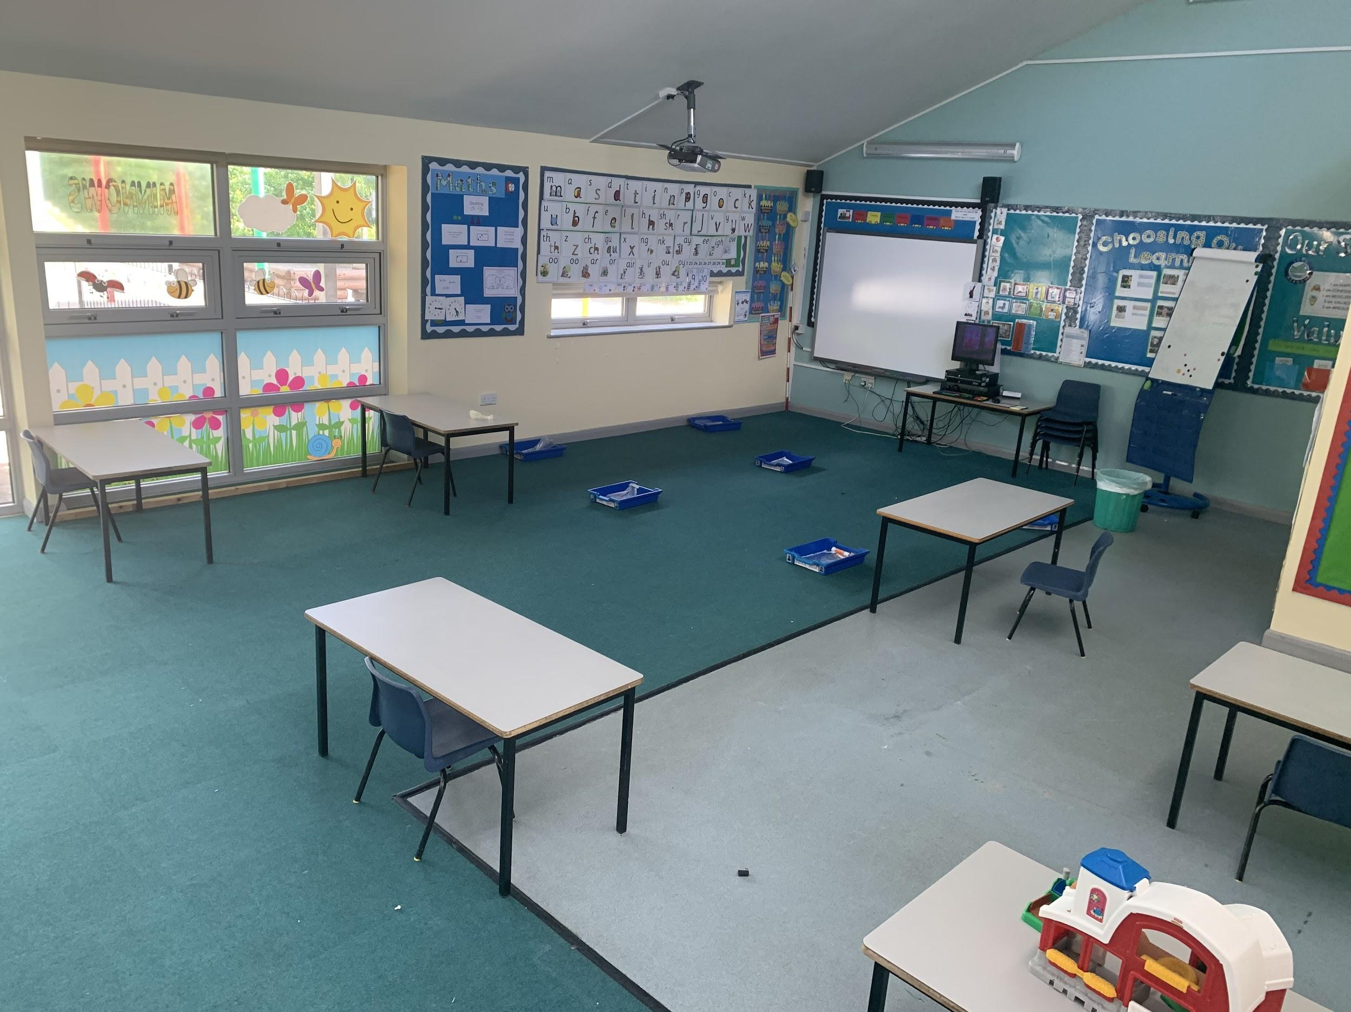

As you can see they are nothing like what we or the children will be used to. Also, to ensure social distancing, our outside areas look very different. The floor has been sprayed with yellow markers to ensure 2m between groups, our entrances have also been taped up to ensure pods do not mix, the one way stems mean people can't stop and chat and spend time on the site: this goes against everything we stand for at LMS, but it is what it is for now.

Applications for returning to school have now closed and parents will receive their allocated classroom for their children today. We will now not be accepting any further children until Monday the 8th June and will continue this on Mondays only from then on. Our classrooms are not set up for more than the numbers we have, thus we need time to reset them on Friday afternoons ready for the following Monday.

This also means that parents who turn up with children on Monday who have not applied for the 1st of June, unfortunately will be asked to return home and apply through the emergency@ email for the 8th June.

Other updates:
- We have been able to release teachers for time during the week to focus on Google Classroom, this means that the impact for those choosing not to return to school should be minimal.
- Some staff across the school have indicated that they wish to wear face masks, so we wanted you to be aware of this.
- A screen has arrived and will be fitted on the reception desk for visitors with appointments.
- We have decided not to remove carpets from classrooms- we will spray them fully on a Friday PM as part of the deep clean each week.
- All staff have been asked to politely challenge any poor social distancing they observe. Please do not be offended if any member of staff asks you or your children to socially distance properly.
- We will be open to critical workers and vulnerable children in Years 2,3, 4 and 5 ONLY on a Friday afternoon. We cannot accept other year groups as we cannot mix pods.
- Pods, once allocated, cannot and will not, be changed.

So what do we need to do if we are returning to school on Monday?
- Please only arrive at the time allocated and not before.
- Enter the site through the staff car park gate and walk around the one way system until you find the letter classroom that your child has been allocated (these are all at the FRONT of the building).
- Drop your child off and immediately re-enter the one way system, exiting through the main gate.
- Please socially distance (2m) AT ALL TIMES.
- The same procedur applies to pick up times as well.
- Email/phone the school office if you need to contact us.
- Email emergency@ if you change your mind and wish to remove your child from school.
- If your child is resisting coming in, please do another lap of the one way system and try again.

What does my child need to bring?
- Sun hat
- Coat
- Packed lunch (if not already ordered one)
- Water bottle
- Hand cream (optional)

What do I do if my child is not returning?
- Continue to access Google classroom in the normal way.
- Email emeregency@ if you are having difficulties with logging in.
- If you are in EYFS, Year 1 or Year 6 and you wish to send your child to school, please email emergency@ and we will allocate your child a pod for the following Monday.

Finally today some documents and links to help. Firstly please find below a link to a video for children about social distancing: it's called ‘While we can't hug’ and tries to explain things in a way they might understand.
https://youtu.be/2PnnFrPaRgY

Secondly (with thanks to Broughton Fields Primary) I attach a social story that might help explain what things will be like when they return to school.

We know things will be different for all of us, but as ever at LMS we will deal with anything that is thrown at us. We have done our best to reduce risks in all areas of school life through reason changes, actions and systems but we can never eliminate the risk.

Stay safe everyone

Best wishes

Mr Gray

Headteacher

