Read Write Inc

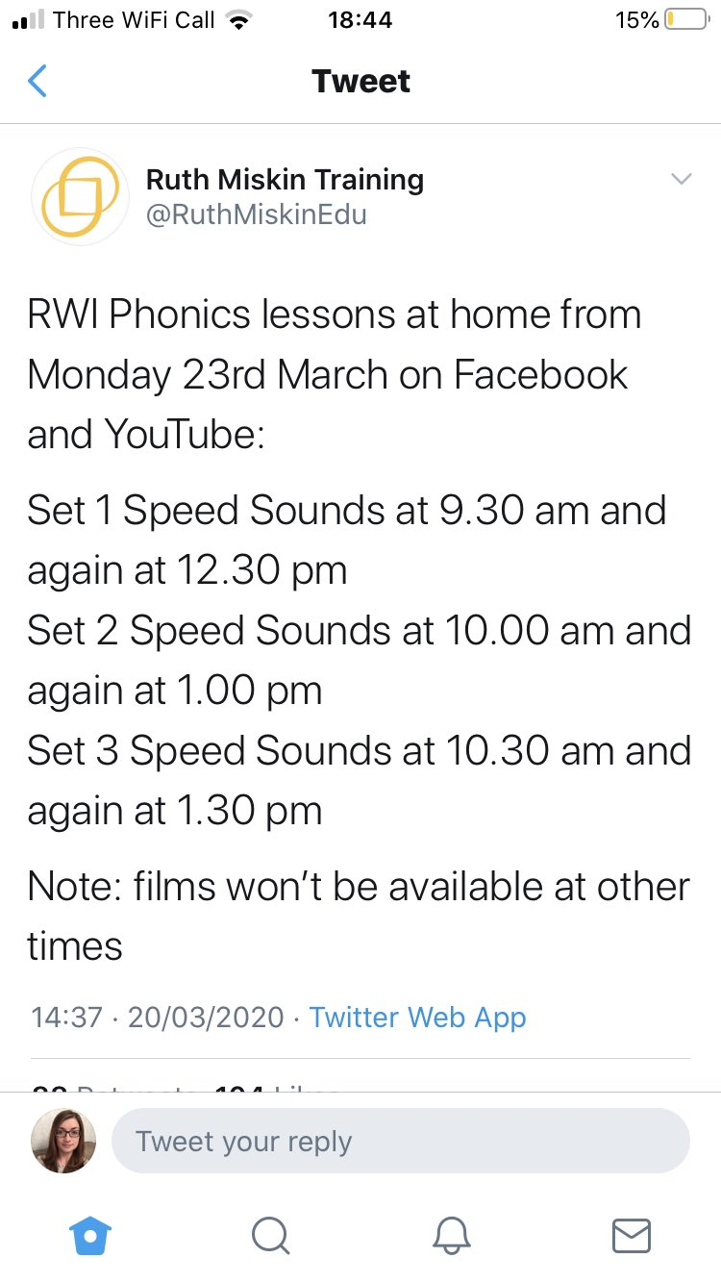

https://www.youtube.com/results?search_query=ruth+miskin

The lessons are available for 24 hours.
Set 1 are initial sounds which most Year 1 children don’t need, however it is really good for letter formation.
Set 2 are easier and Set 3 are harder ‘special friends’. You might like to do both of these, or just one. It’s up to you. Younger and older siblings may also like to join in so that could give you a 20 minute tea break (whilst encouraging them to take part if needed!)

Get Epic login details

Writing Checklist

To write sentences in order to create short narratives and non-fiction texts.
To use some features of different text types (although these may not be consistent).
To reread their writing to check that it makes sense and make suggested changes.
To use adjectives to describe.
To use simple sentence structures.
To use the joining word (conjunction) ‘and’ to link ideas and sentences.
Has an awareness of: | capital letters for names, places, the days of the week and the personal pronoun ‘I’.
 | finger spaces.
 | full stops to end sentences.
 | question marks.
 | exclamation marks.
To spell most words containing previously taught phonemes and GPCs accurately.
To spell most Y1 common exception words and days of the week accurately (from English Appendix 1).
To use -s and -es to form regular plurals correctly.
To use the prefix ‘un’.
To add the suffixes –ing, -ed, -er and –est to root words (with no change to the root word).
To write lower case and capital letters in the correct direction, starting and finishing in the right place.
To write lower case and capital letters in the correct direction, starting and finishing in the right place with a good level of consistency.

Example of sound button-ing words:
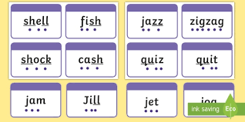

MATHS – Directions in the city:

